Documentation
Project Description:
The project simulates the interaction between university students and teaching assistants (TAs) in the context of a TA office. Students come to the office seeking help with programming problems, and the interactions are organized using synchronization concepts such as Semaphores and Mutex locks in Java.

Objectives:
-1Provide a simulation environment for interactions between students and TAs.
-2Use Semaphores and Mutex locks to control access to resources such as chairs and TA availability.
-3Achieve effective organization of student access and assistance.

Project Components:
-1Mutexlock Class:
Represents a custom lock with conditions for signaling.
take(): Acquires the lock and signals the last condition in the array.
release(): Releases the lock and waits until a signal is received.
-2Student Class:
Implements the Runnable interface, indicating it can be run concurrently.
Students have a certain programTime (time to complete a program) and helpTime (time to get help from a TA).
Utilizes a Mutexlock instance (wakeup), a Semaphore for chairs (chairs), and another Semaphore for availability (available).
In the run() method, students attempt to acquire availability, and if successful, they request help from a TA. If not, they try to sit on a chair. If no chairs are available, they wait for some time before retrying.
-3TeachingAssistant Class:
Implements the Runnable interface.
TAs also use a Mutexlock instance (wakeup), a Semaphore for chairs (chairs), and another Semaphore for availability (available).
In the run() method, TAs release the lock to signal they are available to help students. They then sleep for a certain helpTime. If there are students waiting on chairs, the TA keeps releasing chairs until the maximum number is reached.
Project Execution Scenario:
-1Students arrive at the office and wait in chairs.
-2Access to the TA is organized using Semaphores.
-3Interaction occurs between students and TAs based on priorities and resource availability.
-4Turn-taking among students is organized using Mutex locks.
-5Resources are released once assistance is complete.

The project was developed by:
1-Mohammed Ahmed Marouf
2-Yasser Ahmed Sayed
3-Abdullah Sayed Abdullah
4-Omar Abdullah Abdullah
5-Ahmed Tarek Abu Bakr

the division of the project:
-1Code Implementation:
-Implemented by )Mohammed Ahmed Marouf, Yasser Ahmed Sayed, and Omar Abdullah Abdullah(.
-Involves designing and implementing the code for simulating the interaction between students and teaching assistants using Semaphore and Mutexlock in Java.
-Development of classes such as Student, TeachingAssistant, Office, and any other relevant parts related to the programmatic interaction.

-2Graphical User Interface (GUI):
-Implemented by) Abdullah Sayed Abdullah and Ahmed Tarek Abu Bakr(.
-Includes designing and implementing the graphical user interface (GUI) using JavaFX Scene Builder or any other visual tool.
-Interacts with the backend code to provide a better user experience, such as displaying text or messages when students arrive or assistance is provided.

Threads:
Multithread is used in the project and they are:
1-Student thread
2-TeachingAssistant Thread

This code explains how Threads works:
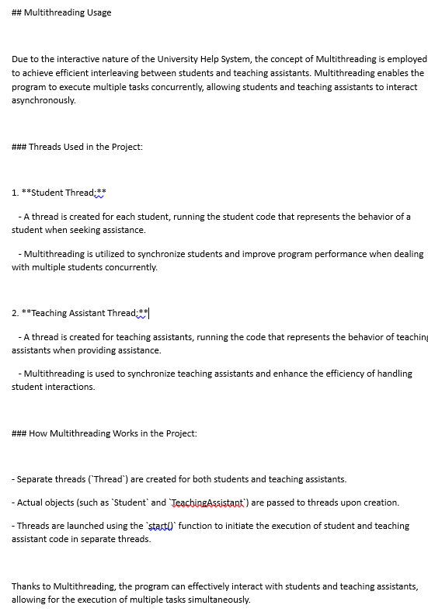

THANK YOU.

